A000-US-IA-Evansville-Angel Mound Area-Mississippian-Effigy Jar-1200 CE

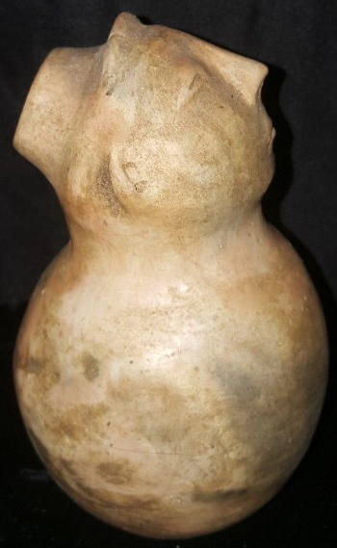 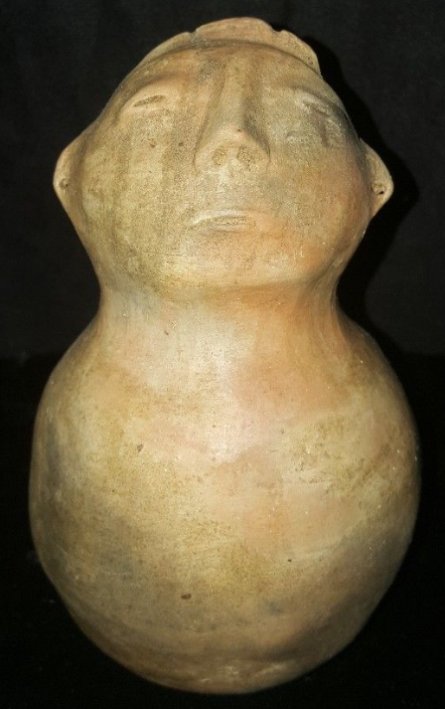 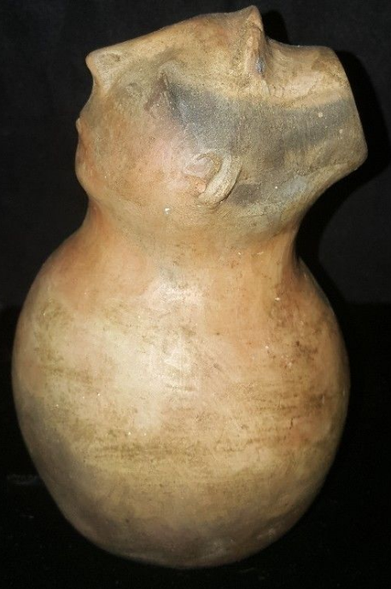

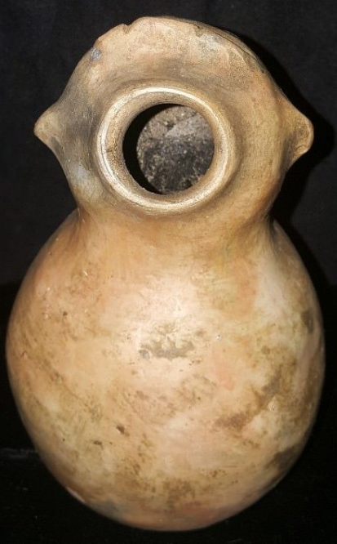 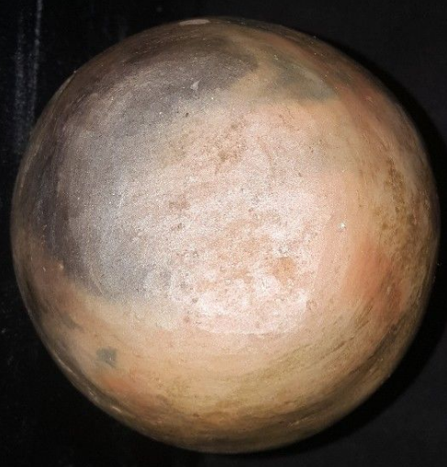

Figs. 1-5. Evansville-Angel Mound Area-Mississippian-Effigy Jar-1200 CE

**Case no.: 12**

**Accession Number:**

**Formal Label:** Evansville-Angel Mound Area-Mississippian-Effigy Jar-1200 CE

**Display Description:**

**Angel Mounds State Historic Site, Indiana,** ([12 VG 1](https://en.wikipedia.org/wiki/Smithsonian_trinomial)) (Pursell, Corin 2004)) is located on the Ohio River in Vanderburgh and Warrick counties and is the site of a town constructed and occupied from 1100-1450 CE as one of the farthest northeastern expressions of the Mississippian culture. The distinctive pottery produced here and in other satellite communities in this section of the Ohio River defines the Angel phase. The use of effigy Jars may have been related to the commemoration of ancestors, and these vessels may have been used for libations ceremonially taken in their honor.

**LC Classification**: E78.I53

**Date or Time Horizon:** 1200 CE

**Geographical Area:** flood plain near Evansville, Indiana

**Map:**

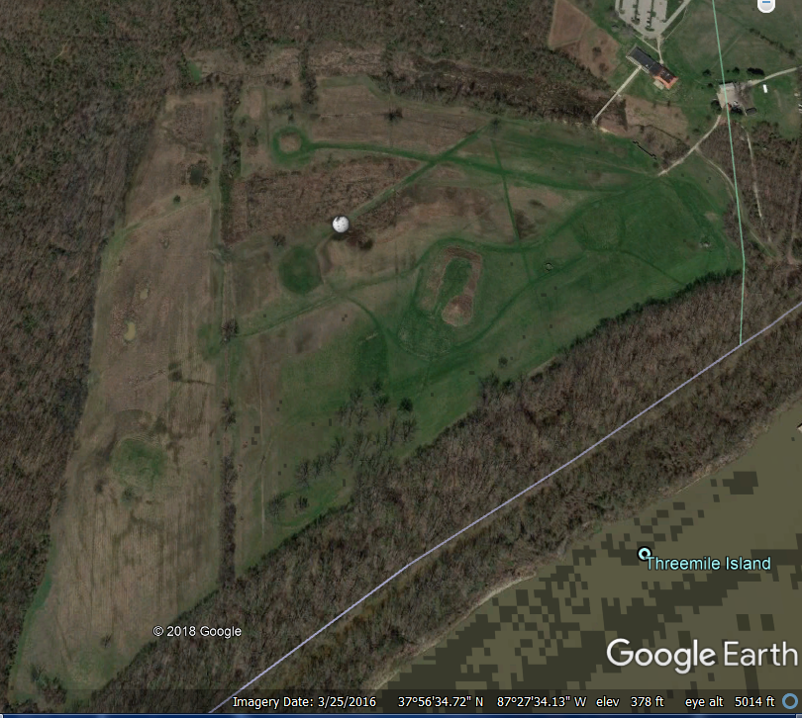

**Angel Site After Google 2018.**

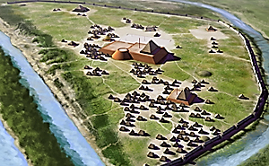

**H Roe’s rendition of the Angel site. After https://upload.wikimedia.org/wikipedia/commons/8/81/Angel_Mounds_HRoe_2015_300px.jpg**

**GPS coordinates:** https://upload.wikimedia.org/wikipedia/commons/thumb/5/55/WMA_button2b.png/17px-WMA_button2b.png[37°56′33″N87°27′26″W](https://tools.wmflabs.org/geohack/geohack.php?pagename=Angel_Mounds&params=37_56_33_N_87_27_26_W_region:US-IN_type:landmark_dim:2000)

**Cultural Affiliation:** Mississippian

**Medium:** clay

**Dimensions:** H 5 in, W 3 in

**Weight:**

**Condition: original**

**Provenance:** The site is named after the Angel family who, from the mid-19th century to 1938, owned the property on which it is located and this vessel was found by them before 1938 probably on the flood plain near Evansville, Indiana.

**Discussion:**

After 1000 CE, people settled a large residential and agricultural community that is the most northeastern of the Mississippian culture, covering 100 acres (0.40 km2). It is situated on a large, terraced earthwork mound including a platform and a defensive 12-foot (3.7 m) wattle and daub stockade with bastions. Angel Mounds was a regional chiefdom that extended its influence for several miles around. Smaller communities were probably politically subordinate to this main site They traded with other chiefdoms and peoples along the Ohio and Mississippi rivers. This settlement was the largest-known town of its time in Indiana. The town may have contained as many as 1,000 inhabitants at its peak (Pollack, David 2004)).

An extended regional drought reduced the maize surpluses that had enabled the concentration of population. In addition, the people may have overhunted, as well as reducing forests by their consumption of wood for the stockade, houses and fires. With the collapse of the chiefdom by 1450, many of the Angel people relocated downriver to the confluence of the Ohio and Wabash rivers. A new Late Mississippian cultural group subsequently emerged as the Caborn-Welborn culture (Pollack, David 2004).

**References:**

Arndts, Paul J.; Gerke, Tammie L.; Elswick, Erika R. (April 24–25, 2008). Characterization of ceramics found inside Late Prehistoric potter's workshop: Angel Mounds Site. Geological Society of America, North-Central Section - 42nd Annual Meeting. Evansville, Indiana: Geological Society of America. pp. 20–11. Retrieved 2012-03-26.

Black, Glenn Albert. *Angel Site, An Archaeological, Historical and Ethnological Study* (with James H. Kellar). Indianapolis: Indiana Historical Society, 1967, 2 volumes.

Hilgeman, Sherri (2000). *Pottery and Chronology at Angel*. University of Alabama Press. pp. 30–31

 Pollack, David (2004). *Caborn-Welborn - Constructing a New Society after the Angel Chiefdom Collapse.*University of Alabama Press.

Pursell, Corin (2004). Geographic distribution and symbolism of colored mound architecture in the Mississippian Southeast(Thesis). Southern Illinois University Carbondale. p. 205.